CS 480
Updated Software Requirements Specification

Document Control

Document Information
© | Information
Document Owner | Team J.A.K.E.
Issue Date | 10/27/2025
Last Saved Date | 10/30/2025
File Name | Upd SRS – Team J.A.K.E.

Document History
Version | Issue Date | Changes
[1.0] | 10/15/2025 | Completed the SRS
[2.0] | 10/27/2025 | Updated the SRS

Table of Contents

1. Introduction 5
1.1 Purpose 5
1.2 Scope of the Project 5
1.3. Glossary 5
1.4 References 7
2. Use Case Diagram 8
3. Use Case Descriptions 8
3.1. Use Case Log In 8
3.1.1. Use Case Log in Description 8
3.1.2. User interfaces 10
3.1.2.1. User Interface: Login Page 10
3.1.3. Functional Requirements 10
3.1.4. Nonfunctional Requirements 11
3.1.5. API Interfaces 11
3.1.5.1. API Call 1 11
3.1.6. Design Constraints 11
3.2. Use Case Display Weather Map 11
3.2.1. Use Case Display Weather Map Description 11
3.2.2. User Interfaces 13
3.2.2.1. User Interface: Display Weather Map 13
3.2.3. Functional Requirements 13
3.2.4. Nonfunctional Requirements 14
3.2.5. API interfaces 14
3.2.5.1. API Google Maps 14
3.2.5.2. API Open Weather Map 15
3.2.6. Design constraints 16
3.3. Use Case Select Location 16
3.3.1 Use Case Select Location Description 16
3.3.2. User Interfaces 17
3.3.2.1. User Interface: Select Location 17
3.3.3. Functional Requirements 17
3.3.4. Nonfunctional Requirements 17
3.3.5. API interfaces 18
3.3.5.1. API Call 18
3.3.6. Design constraints 18
3.4. Use Case Display Weekly Weather Data 18
3.4.1. Use Case Display Weekly Weather Data 18
3.4.2. User Interfaces 19
3.4.2.1. User Interface: Display Weekly Weather Data 19
3.4.3. Functional Requirements 19
3.4.4. Nonfunctional Requirements 19
3.4.5. API Interfaces 20
3.4.5.1. API Open-Meteo 20
3.4.6. Design constraints 21
3.5 Use Case Search Location 21
3.5.1. Use Case Search Location Description 21
3.5.2. User Interfaces 22
3.5.2.1. User Interface: Search Location 22
3.5.3. Functional Requirements 22
3.5.4. Nonfunctional Requirements 22
3.5.5. API Interfaces 22
3.5.5.1. API Google Maps Geocoding 22
3.5.6. Design Constraints 23
3.6. Use Case Manage Locations 23
3.6.1. Use Case Manage Locations Description 23
3.6.2. User Interfaces 24
3.6.2.1. User Interface: Manage Locations 24
3.6.3. Functional Requirements 25
3.6.4. Nonfunctional Requirements 25
3.6.5. API Interfaces 25
3.6.5.1. API Call 25
3.6.6. Design Constraints 25
3.7. Use Case Forgot Password 25
3.7.1. Use Case Forgot Password Description 25
3.7.2. User Interfaces 27
3.7.2.1. User Interface: Forgot Password Page 27
3.7.3. Functional Requirements 27
3.7.4. Nonfunctional Requirements 28
3.7.5. API Interfaces 28
3.7.5.1. API Call 28
3.7.6. Design constraints 28
3.8. Use Case Sign Up 28
3.8.1. Use Case Sign Up Description 28
3.8.2. User Interfaces 29
3.8.2.1. User Interface: Sign Up Page 29
3.8.3. Functional Requirements 30
3.8.4. Nonfunctional Requirements 30
3.8.5. API interfaces 30
3.8.5.1. API Call 30
3.8.6. Design constraints 30
4. Traceability Matrix 31

Introduction

1.1 Purpose
The purpose of this document is to describe the system's use cases, core functionalities, design requirements, design constraints, user interfaces, sequence diagrams, and API calls. It ensures that all project stakeholders share a common understanding of the system's goals, behaviour, and limitations to the development process.

1.2 Scope of the Project
The scope of this project is to successfully design, develop, and deliver a fully functional, authenticated, weather application. The application will serve as a user-centric interface for retrieving, displaying, and managing real-time weather information using external data providers.

In Scope | Not in Scope
Users can save up to 10 favourite locations | Users can save more than 10 favourite locations
Users can switch between favourite locations to see the weather data | Weather data for previous days
Users can view their immediate location | Weather data available for minutes, seconds, and hours
Secure user authentication | Adding an ‘AI’ weather assistant
Users can search for different locations using the weather map | Historical or long-term weather data
Radar display for users' immediate location | Guest access without authentication
Weather data daily (up to 7 days) display | Native mobile app development
Users can update their forgotten password | Notification system alerting the user
Users can switch the map style (e.g. Radar style)
Users can delete from their favorite locations
Users have navigation ability on the weather map

1.3. Glossary
- Actor - a role played by a user, another system, or hardware that interacts with the system by exchanging data and signals
- API – Application Programming Interface
- API Call – Involves sending a message to a server to request a service from an API
- API Google Geolocation – Determines devices geolocation
- API Google Geocoding – Determines latitude and longitude from an address or location
- API Google Maps – Gives the ability to utilize google maps map features
- API Open Meteo Weather – Provides real-time and forecast weather data for specific locations
- API Open Weather Maps – Provides different versions of map such as precipitation and temperature
- Dictionary – Abstract data type that stores a collection of key-value pairs
- Functional Requirements – Specifies what a system must, detailing its specific features, functions, and behaviours to meet user and business needs
- J.A.K.E. – Represents the first letter of each of our names
- Nonfunctional Requirements – specify how a system should perform its functions, focusing on quality attributes like performance, security, usability, and reliability, rather than what functions it performs
- Requirements Traceability Matrix – Project requirements in relation to design and test cases
- Sequence Diagram - type of Unified Modelling Language (UML) diagram that illustrates how objects or systems interact with each other over time through a series of messages
- SRS – Software requirement specifications for our project
- Use Case Description – Outlines the specific steps an actor takes to interact with a system
- Use Case Diagram – UML diagram used to define system scope and identify functional requirements
- User Interface – The space where interaction between the users and the system occurs
- WMO Weather Code – Refers to the standardized, internationally recognized numerical weather code from World Meteorological Organization (WMO)

1.4 References
- API Open Meteo Weather. This API will be the main source of our weather data, offering weekly weather for specified locations.
https://open-meteo.com/en/docs/historical-weather-api

- API Google Geolocation. We will use this API to get the user’s current location.
https://developers.google.com/maps/documentation/geolocation/overview

- API Google Maps. This API will be apart of our Weather Map feature, ensuring that we have a clean and responsive map.
https://mapsplatform.google.com/lp/maps-apis/

- API Google Geocoding. This API will be apart of the Manage Locations feature, where the newly added location will be converted to latitude and longitude. We need this information for the Open Meteo Weather API.
https://developers.google.com/maps/documentation/geocoding/overview

- API Open Weather Maps. We will use this API to display a radar style weather map of the user’s current or specified location.
https://openweathermap.org/api/weathermaps

- WMO Code Table 4677. This Website give information of weather codes which provided from Open-Meteo Weather API. Weather codes will determine which weather icons we are using for the weekly weather data.
https://www.nodc.noaa.gov/archive/arc0021/0002199/1.1/data/0-data/HTML/WMO-CODE/WMO4677.HTM

Use Case Diagram
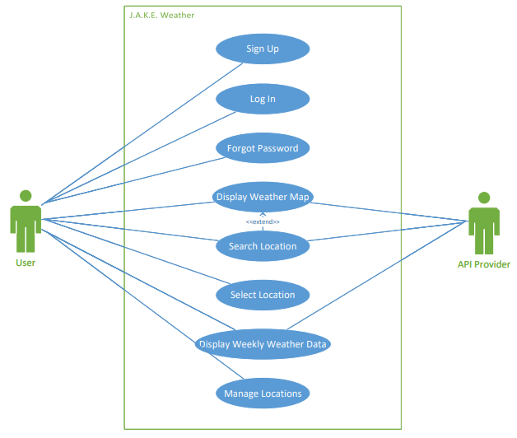

Use Case Descriptions

3.1. Use Case Log In
The Log In Use Case involves the secure login of user accounts in the weather application.

3.1.1. Use Case Log in Description
Use Case Name: | Log In
Use Case Id: | UC-1
Priority: | High
Source: | Professor White
Primary Business Actor: | User
Other Participating Actors: | N/A
Description: | Users can securely log in to their account
Pre-Condition: | User is on the login landing page
Trigger: | User enters their username and password into the login page
Typical Course | Actor Action | System Response
Of Events: | Step 1: User enters username and password
 | Step 2: User clicks the Log In button | Step 3: The system checks if the user has an account
 |  | Step 4: The system displays a successful login message
 |  | Step 5: The system redirects the user to their dashboard
Alternate Courses: | Step 1: User enters username and password
 | Step 2: User clicks the Log In button | Step 3: The system failed to authenticate the user
 |  | Step 4: The system displays an appropriate error message
Conclusion: | The system successfully logs the user into their account
Post-Condition: | The user successfully accesses their dashboard
Business Rules | The system must allow users to securley log into their account
Implementation Constraints and Specifications | The user must have a unique username
Assumptions: | The user has access to the internet
Open Issues: | N/A

3.1.2. User interfaces

3.1.2.1. User Interface: Login Page
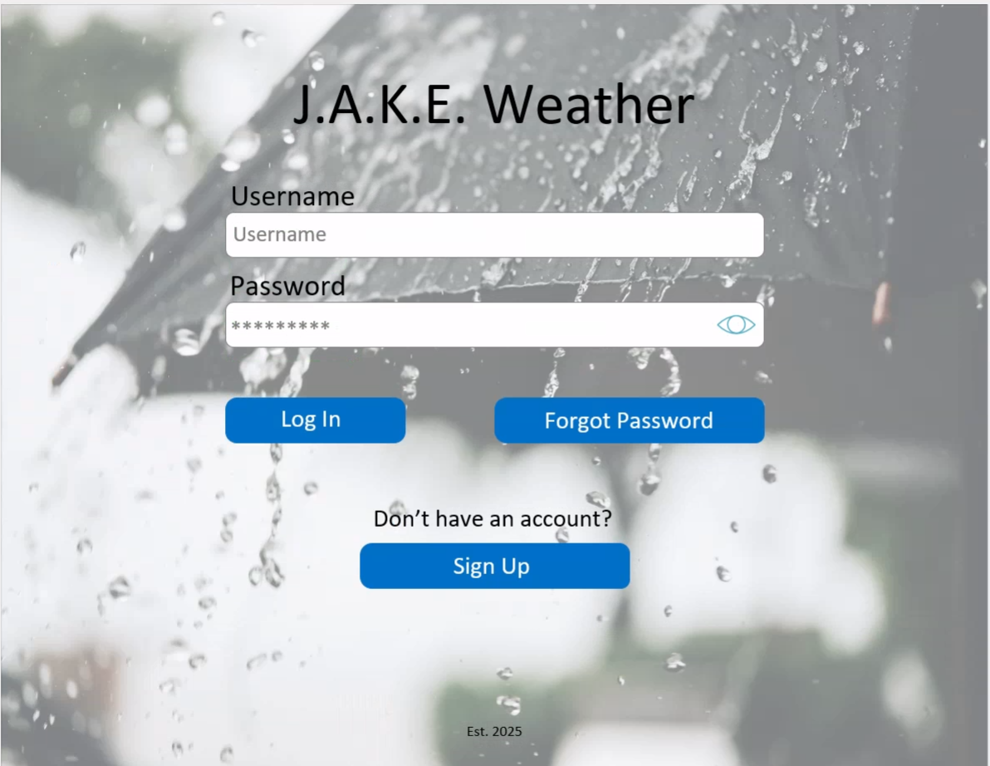

Data Item | Origin
Username | User
Password | User

3.1.3. Functional Requirements

Identifier | Description
UC-1-F-1 | The user’s username must be between 5 and 40 characters long and are able to contain special characters
UC-1-F-2 | The user’s password must be between 5 and 20 characters long and contain at least one special character, capitol letter, and number
UC-1-F-3 | The password eye button must toggle the password between hidden and un-hidden
UC-1-F-4 | Upon unsuccessful login, an appropriate error message will be displayed
UC-1-F-5 | Usernames must be unique
UC-1-F-6 | The system must not allow users to continue to the dashboard if their account has not been authorized
UC-1-F-7 | Clicking the Forgot Password button must redirect the user to the forgot password screen
UC-1-F-8 | Clicking the Sign-Up button must redirect the user to the sign-up screen
UC-1-F-9 | The system must hash all passwords in a secure manner
UC-1-F-10 | After the password has been successfully hashed, the system must store in a secure manner
UC-1-F-11 | All Log In data should be stored in the system

3.1.4. Nonfunctional Requirements

Identifier | Description
UC-1-NF-1 | The Log In page must be designed so users can log into their account within 2 minutes without assistance to improve overall ease of use

3.1.5. API Interfaces

3.1.5.1. API Call 1
N/A

3.1.6. Design Constraints
- No extra costs will be required for storing user data

3.2. Use Case Display Weather Map
The Weather Map displays a geographical map of the user’s current/selected location by default and can change to other map styles (wind speed, temperature, and precipitation). The layout of the map will be fully dynamic and change depending on the user’s choice. Additionally, users can navigate through the responsive map.

3.2.1. Use Case Display Weather Map Description
Use Case Name: | Display Weather Map
Use Case Id: | UC-2
Priority: | High
Source: | Professor White
Primary Business Actor: | User
Other Participating Actors: | Google Maps API, Open Weather Map API
Description: | User can view their current/selected location on different styles of the map
Pre-Condition: | User successfully logged into the Weather App and has solid internet connection
Trigger: | User’s dashboard has successfully loaded
Typical Course | Actor Action | System Response
Of Events: |  | Step 1: Google Maps API renders the geographical map with the user’s current geolocation
 | Step 2: User clicks the button which changes the layout of the map | Step 3: Open Weather Map API receives user’s request
 |  | Step 4: Open Weather Map API re-renders the appropriate map as user required
 |  | Step 5: Open Weather Map API displays the rendered map on the user dashboard
Alternate Courses: |  | Step 1: Open Weather Map API failed to render the weather map
 |  | Step 2: System displays error messages onto the user’s dashboard detailing the render fail
Conclusion: | Weather Map successfully renders the correct location
Post-Condition: | User can see the initial/updated data through the weather map
Business Rules | User can successfully view the weather map
Implementation Constraints and Specifications | Weather App can display geographical (default), wind speed, temperature, and precipitation style map  Weather Map is limited to certain locations (due to limitation of data)
Assumptions: | User has access to the internet and GPS connection
Open Issues: | Loading time for the Weather Map may suffer due to internet speed and/or speed of API fetches

3.2.2. User Interfaces

3.2.2.1. User Interface: Display Weather Map
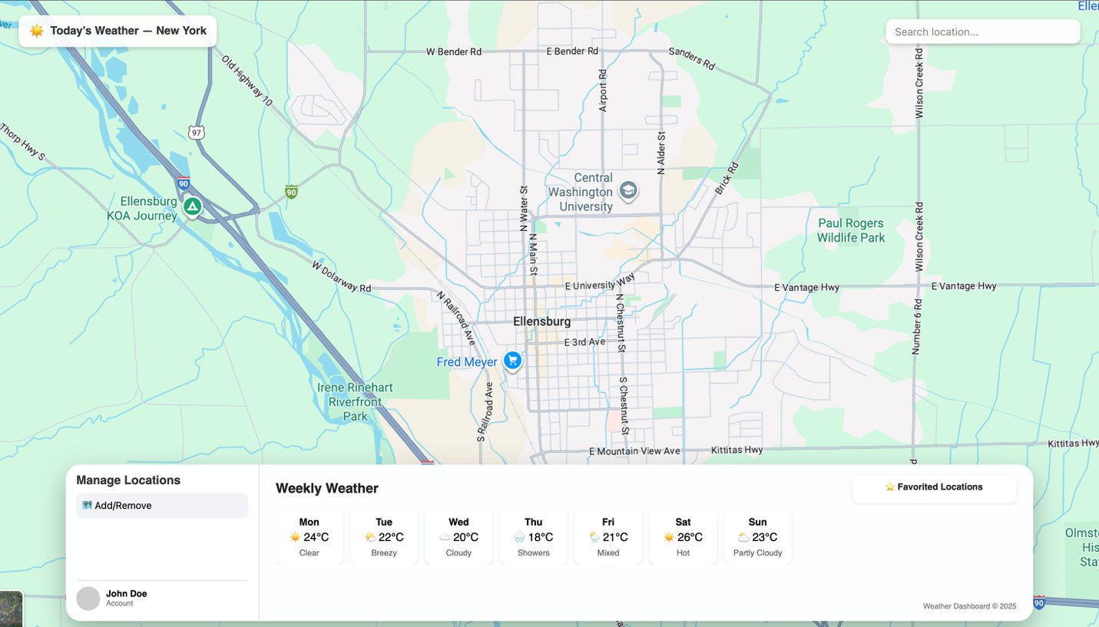

Data Item | Origin
Geological Map | Google Maps API
Precipitation Map | Open Weather Map API
Wind Speed Map | Open Weather Map API
Temperature Map | Open Weather Map API

3.2.3. Functional Requirements

Identifier | Description
UC-2-F-1 | The Weather Map must be able to display a geographical map of the current/selected location
UC-2-F-2 | The Weather Map must be able to display a precipitation map of the current/selected location
UC-2-F-3 | The Weather Map must be able to display a wind speed map of the current/selected location
UC-2-F-4 | The Weather Map must be able to display a temperature map of the current/selected location
UC-2-F-5 | The user must be able to zoom in on all the map styles
UC-2-F-6 | The user must be able to zoom out on all the map styles
UC-2-F-7 | The user must be able to move around on all the map styles
UC-2-F-8 | The user must only be able to view one map at a time

3.2.4. Nonfunctional Requirements

Identifier | Description
UC-2-NF-1 | The size of the weather map must cover the user’s entire window
UC-2-NF-2 | The system must be able to render and display all map styles within 2 seconds

3.2.5. API interfaces

3.2.5.1. API Google Maps

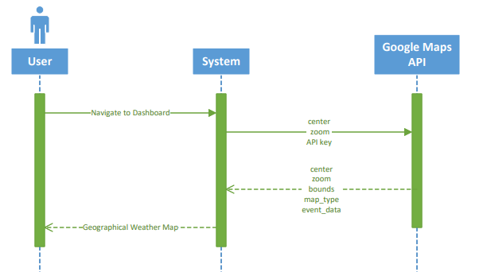

Data Items Sent to the API | Datatype and Size | Comments
center | dictionary  {longitude: float,  Latitude: float,  elevation: float,  generationtime_ms:float, utc_offset_seconds: float,  timezone: string,  timezone_abbreviation: string,  hourly: list,  hourly_units:{string:string}  } | Initial center coordinates
zoom | integer | Initial zoom level
api_key | string | Unique API key which provided from API provider

Data Items Returned by the API | Datatype and Size | Comments
center | dictionary  {longitude: float,  Latitude: float,  elevation: float,  generationtime_ms:float, utc_offset_seconds: float,  timezone: string,  timezone_abbreviation: string,  hourly: list,  hourly_units:{string:string}  } | Current center coordinates
zoom | integer | Current zoom level
bounds | string | Current map’s bounds
map_type | string | Currently displayed map type
event_data | list | Data interactions from user interactions

3.2.5.2. API Open Weather Map

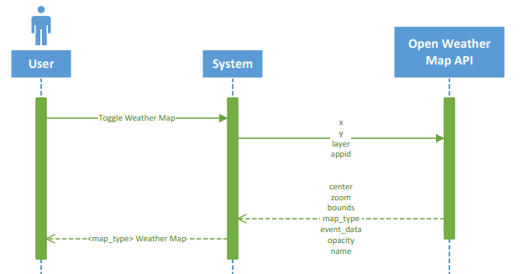

Data Items Sent to the API | Datatype and Size | Comments
x | floating point | Number of x title coordinate of the current location
y | floating point | Number of u title coordinate of the current location
layer | string | Layer name
appid | string | Unique API key which provided from API provider

Data Items Returned by the API | Datatype and Size | Comments
center | Dictionary  {longitude: float,  latitude: float  } | Current center coordinates
zoom | integer | Current zoom level
bounds | string | Current map’s bounds
map_type | list | Currently displayed map type
event_data | list | Data interactions from user interactions
opacity | floating point | A number (0.0 - 1.0) that controls transparency
name | string | Optional display name for your layer

3.2.6. Design constraints
- No extra costs required for using APIs

3.3. Use Case Select Location
The Select Location feature allows for users to choose between their favorited locations.

3.3.1 Use Case Select Location Description
Use Case Name: | Select Location
Use Case Id: | UC-3
Priority: | High
Source: | Professor White
Primary Business Actor: | User
Other Participating Actors: | N/A
Description: | Users should be able to select their favorite locations
Pre-Condition: | User is logged in
Trigger: | User clicks on one of their favorite locations
Typical Course | Actor Action | System Response
Of Events: | Step 1: User clicks on one of their favorite locations | Step 2: System gathers necessary information for the selected location
 |  | Step 3: System displays new dashboard with gathered information
 | Actor Action | System Response
Alternate Courses: | Step 1: User clicks on one of their favorite locations | Step 2: System fails to gather necessary information for the selected location
 |  | Step 3: System displays error messages onto the user’s dashboard detailing the issue
Conclusion: | Weather App successfully updates according to the user’s selected favorite location
Post-Condition: | User can see the updated dashboard correlating to the selected favorite location
Business Rules | User must be able to select between their favorite locations
Implementation Constraints and Specifications | Users cannot have more than 10 favorite locations
Assumptions: | The user has at least 2 favorite locations saved in the weather map
Open Issues: | N/A

3.3.2. User Interfaces

3.3.2.1. User Interface: Select Location
Refer to 3.2.2.1 User Interface: Display Weather Map

Data Item | Origin
Favorite Location List | User Input
Favorite Location | User Input

3.3.3. Functional Requirements

Identifier | Description
UC-3-F-1 | Weather App must display all the users’ favorite locations in the favorite locations section on the dashboard
UC-3-F-2 | The overall weather application must be updated according to the most recently clicked favorite location
UC-3-F-3 | The user’s current location must be at the top of the favorited location list
UC-3-F-4 | Each favorite location must show their appropriate city and abbreviated state in the following format: <Ellensburg, WA>
UC-3-F-5 | The user must only select one location from their favorite locations list at a time

3.3.4. Nonfunctional Requirements

Identifier | Description

3.3.5. API interfaces

3.3.5.1. API Call
N/A

3.3.6. Design constraints
- N/A

3.4. Use Case Display Weekly Weather Data
The weather app successfully and accurately displays the weekly weather data on the dashboard starting from the current day.

3.4.1. Use Case Display Weekly Weather Data
Use Case Name: | Display Weekly Weather Data
Use Case Id: | UC-4
Priority: | High
Source: | Professor White
Primary Business Actor: | User
Other Participating Actors: | Open-Meteo API
Description: | The weather app successfully and accurately fetches and displays the weekly weather data on the dashboard starting from the current day.
Pre-Condition: | User must be logged in
Trigger: | The dashboard page successfully loaded
Typical Course | Actor Action | System Response
Of Events: |  | Step 1: The system successfully renders the user dashboard page
 |  | Step 2: Open-Meteo API requests weather data on user’s current location or user’s newly selected location
 |  | Step 3: System updates the weekly weather with the data retrieved from Open-Meteo API
 | Actor Action | System Response
Alternate Courses: |  | Step 1: The system successfully renders the user dashboard page
 |  | Step 2: Open-Meteo API fails to retrieve the data for user’s request
 |  | Step 3: The system displays the error message
Conclusion: | Weather app successfully displays the correct weekly data
Post-Condition: | User can see the weekly weather data of the current/select location
Business Rules | Weather app must display the weather data of the current/selected location
Implementation Constraints and Specifications | Weather data can only be displayed up to 7 days after the current day  Weather app is limited to certain locations (due to limitation of data)
Assumptions: | User has access to the internet and GPS connection
Open Issues: | Loading times for displaying the weekly weather data may suffer due to bad internet connection or API issues

3.4.2. User Interfaces

3.4.2.1. User Interface: Display Weekly Weather Data
Refer to 3.2.2.1 User Interface: Display Weather Map

Data Item | Origin
Weekly Weather Data | Open-Meteo API

3.4.3. Functional Requirements

Identifier | Description
UC-4-F-1 | Upon successful login, the system shall retrieve weather data for the user's current location from a weather data provider within 2 seconds
UC-4-F-2 | The system must update weather data when the user has refreshed the page
UC-4-F-3 | The system must update weather data when the user selects a different favorite location
UC-4-F-4 | The Weather App must display icons that represent the status of weather for all days
UC-4-F-5 | The weekly weather data must display the correct day, icon, and temperature in the following format: <Mon, Icon, 55°F>

3.4.4. Nonfunctional Requirements

Identifier | Description

3.4.5. API Interfaces

3.4.5.1. API Open-Meteo

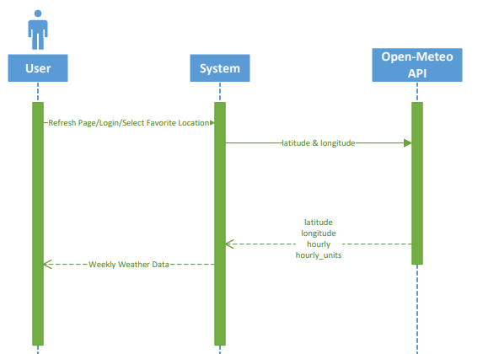

Data Items Sent to the API | Datatype and Size | Comments
latitude | floating point | Latitude required to receive the weather data from Open-Meteo API
longitude | floating point | Longitude required to receive the weather data from Open-Meteo API

Data Items Returned by the API | Datatype and Size | Comments
latitude | floating point | Latitude of the current location
longitude | floating point | Longitude of the current location
hourly | dictionary  {string : list} | For each selected weather variable, data will be returned as a string list key value pair dictionary
hourly_units | dictionary  {string : string} | For each selected weather variable, the unit will be listed here as a string string key value pair dictionary

3.4.6. Design constraints
- No extra costs required for using APIs

3.5 Use Case Search Location
The weather app allows users to search for new locations using the weather map feature. Upon successful search, the weather map must display the new location that users searched.

3.5.1. Use Case Search Location Description
Use Case Name: | Search Location
Use Case Id: | UC-5
Priority: | Medium
Source: | Professor White
Primary Business Actor: | User
Other Participating Actors: | Google Maps Geocoding API
Description: | Users can search for new locations allowing for the weather map to be updated upon successful search
Pre-Condition: | User must be logged in, user must have access to the internet, weather map must be fully rendered
Trigger: | User searches for a new location
Typical Course | Actor Action | System Response
Of Events: | Step 1: User searches for the new location on the weather map | Step 2: Google Maps Geocoding API receives the new location
 |  | Step 3: Google Maps Geocoding API logs the latitude and longitude of the new location
 |  | Step 4: System renders the updated weather map with updated latitude and longitude
 | Actor Action | System Response
Alternate Courses: | Step 1: User searches for the new location on the weather map | Step 2: Google Maps Geocoding API failed to receive the new location
 |  | Step 3: The System displays error messages detailing the Google Maps Geocoding API failed
Conclusion: | User has successfully searched for the new location
Post-Condition: | User can see the appropriate location on the weather map
Business Rules | User can search for new locations on the weather map
Implementation Constraints and Specifications | User can only search for new locations on the geographical map
Assumptions: | User must have internet and GPS connection
Open Issues: | N/A

3.5.2. User Interfaces

3.5.2.1. User Interface: Search Location
Refer to 3.2.2.1 User Interface: Display Weather Map

Data Item | Origin
Search Bar Input | User

3.5.3. Functional Requirements

Identifier | Description
UC-5-F-1 | Users must be able to search for new locations using the search bar on the Weather Map
UC-5-F-2 | If the user’s searched location cannot be found, the system must display an appropriate error message
UC-5-F-3 | The system only allows users to search for new locations using an address, city, state, country, or generic place name
UC-5-F-4 | The search bar must be located at the top-right corner of the Weather Map
UC-5-F-5 | If the user provides a valid address, the system must zoom to the address
UC-5-F-6 | If the user provides a valid city, the system must zoom to the city
UC-5-F-7 | If the user provides a valid state, the system must zoom to the state
UC-5-F-8 | If the user provides a country, the system must zoom to the country
UC-5-F-9 | If the user provides a generic place name, the system must zoom to the generic place name

3.5.4. Nonfunctional Requirements

Identifier | Description
UC-5-NF-1 | Upon successful search, the Weather Map must zoom to the user’s searched location within 2 seconds

3.5.5. API Interfaces

3.5.5.1. API Google Maps Geocoding
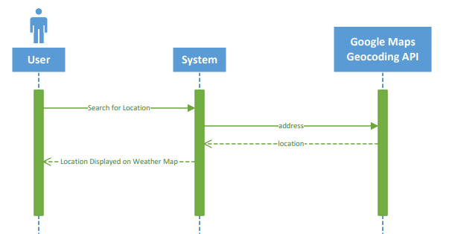
searched location

Data Items Sent to the API | Datatype and Size | Comments
searched location | string | The location the user searched for (address, city, state, country, or generic place name)

Data Items Returned by the API | Datatype and Size | Comments
location | dictionary  { lat: float,  long: float } | The location includes the latitude and longitude of the location

3.5.6. Design Constraints
- No extra costs required for using APIs

3.6. Use Case Manage Locations
The Weather App allows users to add, edit, and delete their favorited locations using the Manage Locations pop-up feature.

3.6.1. Use Case Manage Locations Description
Use Case Name: | Manage Locations
Use Case Id: | UC-6
Priority: | High
Source: | Professor White
Primary Business Actor: | User
Other Participating Actors: | N/A
Description: | This use case describes how a user manages their favorite locations within the system
Pre-Condition: | The user must be logged into the system and must have at least 2 favorite locations
Trigger: | The user clicks on the Manage Locations button
Typical Course | Actor Action | System Response
Of Events: | Step 1: The user clicks on the Manage Locations button | Step 2: The system opens the Manage Locations interface
 | Step 3: The user enters new location details | Step 4: The system validates and verifies the new location details
 |  | Step 5: The system stores the new location details
 |  | Step 6: The system automatically refreshes the Manage Locations interface, detailing the new location was added successfully
Alternate Courses: | Step 1: The user clicks on the Manage Locations button | Step 2: The system opens the Manage Locations interface
 | Step 3: The user enters new location details | Step 4: The System validates and verifies the new location details
 |  | Step 5: System notifies users new location is invalid or unavailable
 |  | Step 6: System displays an appropriate error message or highlights invalid or missing fields
Conclusion: | The user's location data is successfully managed with functions to add, update, and delete their favorite locations
Post-Condition: | All modifications to location data are saved in the user's account, ensuring that the user can see their updated modifications
Business Rules | The user can successfully manage their favorited locations
Implementation Constraints and Specifications | Must store favorite location data securely
Assumptions: | The user’s device has internet access
Open Issues: | N/A
3

3.6.2. User Interfaces

3.6.2.1. User Interface: Manage Locations

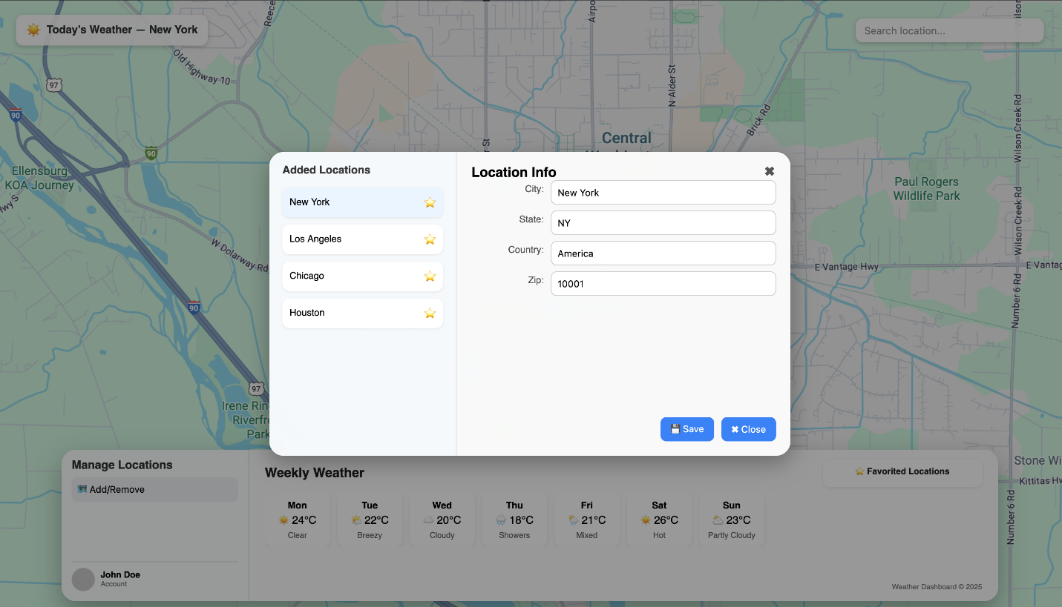

Data Item | Origin
City Info | User Input
State Info | User Input
Country Info | User Input
Zip Info | User Input

3.6.3. Functional Requirements

Identifier | Description
UC-6-F-1 | Users must be able to successfully add a new favorite location using the Manage Locations interface
UC-6-F-2 | Users must be able to successfully remove any location they have added or favorited using the Manage Locations interface
UC-6-F-3 | Users must be able to edit any favorite location using the Manage Locations interface

3.6.4. Nonfunctional Requirements

Identifier | Description
UC-6-NF-1 | The user’s current location must be at the top of the favorited location list
UC-6-NF-2 | The system must securely store the user’s favorited location data
UC-6-NF-3 | The system must display all user’s locations within two 2 seconds of loading the Manage Locations interface

3.6.5. API Interfaces

3.6.5.1. API Call
N/A

3.6.6. Design Constraints
N/A

3.7. Use Case Forgot Password
The Forgot Password feature enables the user to reset their password upon forgetting their pre-existing password.

3.7.1. Use Case Forgot Password Description
Use Case Name: | Forgot Password
Use Case Id: | UC-7
Priority: | Medium
Source: | Professor White
Primary Business Actor: | User
Other Participating Actors: | N/A
Description: | The user can reset their password through the forgot password feature
Pre-Condition: | The user has forgotten their password
Trigger: | The user clicks the Forgot Password button on the login page
Typical Course | Actor Action | System Response
Of Events: | Step 1: The user enters their username
 | Step 2: The user enters their new password and confirmed password
 | Step 3: The user clicks the update button | Step 4: The system validates the user input
 |  | Step 5: The system searches if username has an account
 |  | Step 6: The system resets the user’s pre-existing password with the new password
 |  | Step 7: The system displays a confirmation message
 |  | Step 8: The system redirects the user to the login page
Alternate Courses: | Step 1: The user enters their username
 | Step 2: The user enters their new password and confirmed password
 | Step 3: The user clicks the Reset Password button | Step 4: The system validates the user input
 |  | Step 5: The system fails to find an account for the username
 |  | Step 6: The system displays a failure message
Conclusion: | The user resets their forgotten password with a new password
Post-Condition: | The user is able to successfully login to their account using their new password
Business Rules | The system must help users resolve a forgotten password
Implementation Constraints and Specifications | There is no verification that the user is the real user when updating their password (only need to know the username)
Assumptions: | The user already has an account, the user has stable internet access
Open Issues: | N/A

3.7.2. User Interfaces

3.7.2.1. User Interface: Forgot Password Page
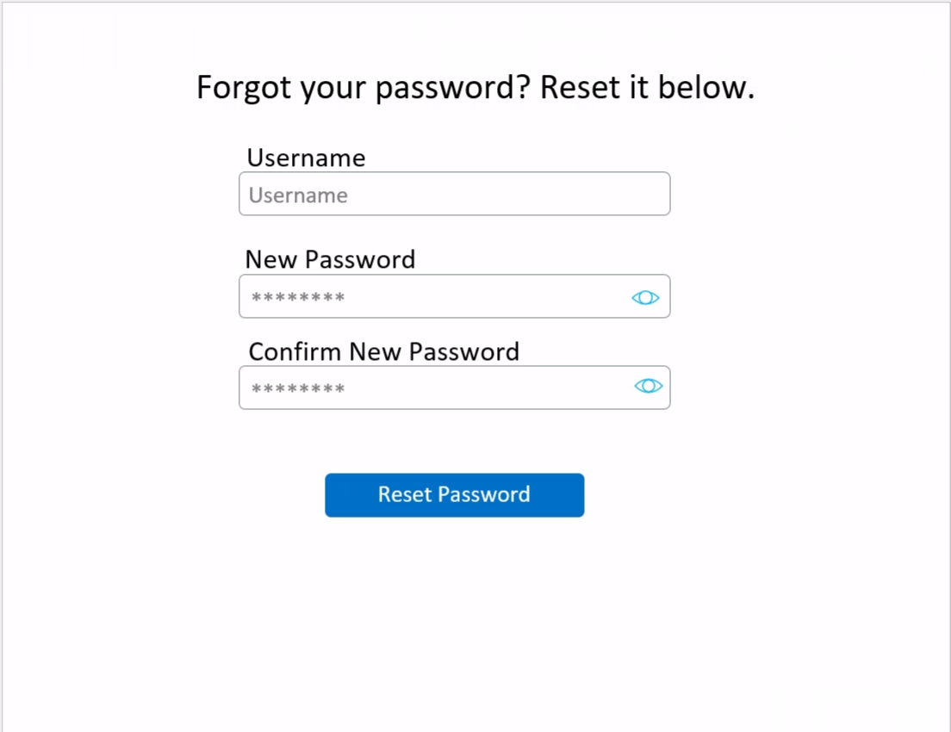

Data Item | Origin
Username | User
New Password | User
Confirm New Password | User

3.7.3. Functional Requirements

Identifier | Description
UC-7-F-1 | Upon unsuccessful password update, the system must display a failure message
UC-7-F-2 | The user’s updated password and confirmed password must be between 5 and 20 characters long and contain at least one special character, capital letter, and number
UC-7-F-3 | The password eye button must toggle the updated password between hidden and un-hidden
UC-7-F-4 | The password eye button must toggle the confirmed password between hidden and un-hidden
UC-7-F-5 | The updated password must match the confirmed password
UC-7-F-6 | The updated password must not be the exact same as the pre-existing password
UC-7-F-7 | The system must display an appropriate error message if the user’s password and confirmed password are not matching
UC-7-F-8 | The system must hash user’s updated password in a secure manner
UC-7-F-9 | After the user’s updated password is successfully hashed, the system must store in a secure manner

3.7.4. Nonfunctional Requirements

Identifier | Description
UC-7-NF-1 | The loading time for resetting a forgotten password must take less than 2 seconds to complete

3.7.5. API Interfaces

3.7.5.1. API Call
N/A

3.7.6. Design constraints
N/A

3.8. Use Case Sign Up
The Sign Up Use Case involves the secure creation of user accounts in the weather application.

3.8.1. Use Case Sign Up Description
Use Case Name: | Sign Up
Use Case Id: | UC-8
Priority: | High
Source: | Professor White
Primary Business Actor: | User
Other Participating Actors: | N/A
Description: | The user can securely create an account in the weather application
Pre-Condition: | The user does not have an account; user is on the Log In page
Trigger: | The user clicks the Sign-Up button
Typical Course | Actor Action | System Response
Of Events: | Step 1: User clicks the Sign-Up button | Step 2: The system redirects to the sign-up page
 | Step 3: User enters the required information
 | Step 4: User clicks the Sign-Up button | Step 5: System validates the user inputs
 |  | Step 6: System displays a successful sign-up message
 |  | Step 7: System redirects user to the login page
Alternate Courses: | Step 1: User clicks the Sign-Up button | Step 2: The system redirects to the sign up page
 | Step 3: User enters the required information
 | Step 4: User clicks the Sign Up button | Step 5: The system fails to validate the user input
 |  | Step 6: The system displays a failure message
Conclusion: | The system successfully creates an account for the user
Post-Condition: | The user is able to successfully login to their newly created account
Business Rules | The system must allow users to securely create an account
Implementation Constraints and Specifications | The user must have a unique username
Assumptions: | User has access to the internet
Open Issues: | N/A

3.8.2. User Interfaces

3.8.2.1. User Interface: Sign Up Page
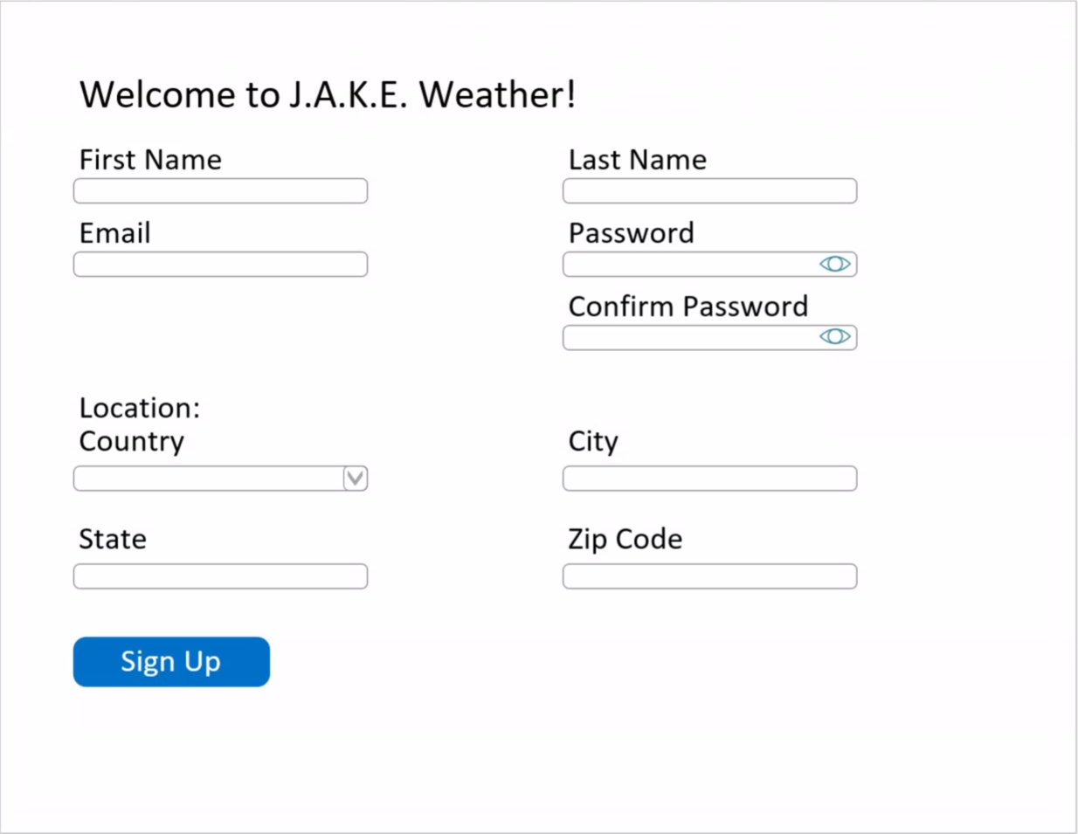

Data Item | Origin
First Name | User
Last Name | User
Email | User
Password | User
Confirm Password | User
Location Country | User
City | User
State | User
Zip Code | User

3.8.3. Functional Requirements

Identifier | Description
UC-8-F-1 | The user’s username must be between 5 and 40 characters long and be able to contain special characters
UC-8-F-2 | The user’s password must be between 5 and 20 characters long and contain at least one special character, capitol letter, and number
UC-8-F-3 | The password eye button must toggle the password and confirm password between hidden and un-hidden
UC-8-F-4 | Upon unsuccessful sign up, an appropriate error message will be displayed
UC-8-F-5 | Usernames must be unique
UC-8-F-6 | The system must hash all password in a secure manner
UC-8-F-7 | After the password is successfully hashed, the system must store in a secure manner
UC-8-F-8 | The system must store all user credentials and location information in a secure manner

3.8.4. Nonfunctional Requirements
Identifier | Description
UC-8-NF-1 | The Sign Up page must be designed so users can create an account within 2 minutes without assistant to improve overall ease of use

3.8.5. API interfaces

3.8.5.1. API Call
N/A

3.8.6. Design constraints
N/A

Traceability Matrix
Use Case Name | Requirement ID
Log In | UC-1-F-1
Log In | UC-1-F-2
Log In | UC-1-F-3
Log In | UC-1-F-4
Log In | UC-1-F-5
Log In | UC-1-F-6
Log In | UC-1-F-7
Log In | UC-1-F-8
Log In | UC-1-F-9
Log In | UC-1-F-10
Log In | UC-1-F-11
Log In | UC-1-NF-1
Display Weather Map | UC-2-F-1
Display Weather Map | UC-2-F-2
Display Weather Map | UC-2-F-3
Display Weather Map | UC-2-F-4
Display Weather Map | UC-2-F-5
Display Weather Map | UC-2-F-6
Display Weather Map | UC-2-F-7
Display Weather Map | UC-2-F-8
Display Weather Map | UC-2-NF-1
Display Weather Map | UC-2-NF-2
Select Location | UC-3-F-1
Select Location | UC-3-F-2
Select Location | UC-3-F-3
Select Location | UC-3-F-4
Select Location | UC-3-F-5
Display Weekly Weather Data | UC-4-F-1
Display Weekly Weather Data | UC-4-F-2
Display Weekly Weather Data | UC-4-F-3
Display Weekly Weather Data | UC-4-F-4
Display Weekly Weather Data | UC-4-F-5
Search Location | UC-5-F-1
Search Location | UC-5-F-2
Search Location | UC-5-F-3
Search Location | UC-5-F-4
Search Location | UC-5-F-5
Search Location | UC-5-F-6
Search Location | UC-5-F-7
Search Location | UC-5-F-8
Search Location | UC-5-F-9
Search Location | UC-5-NF-1
Manage Locations | UC-6-F-1
Manage Locations | UC-6-F-2
Manage Locations | UC-6-F-3
Manage Locations | UC-6-NF-1
Manage Locations | UC-6-NF-2
Manage Locations | UC-6-NF-3
Forgot Password | UC-7-F-1
Forgot Password | UC-7-F-2
Forgot Password | UC-7-F-3
Forgot Password | UC-7-F-4
Forgot Password | UC-7-F-5
Forgot Password | UC-7-F-6
Forgot Password | UC-7-F-7
Forgot Password | UC-7-F-8
Forgot Password | UC-7-F-9
Forgot Password | UC-7-NF-1
Sign up | UC-8-F-1
Sign up | UC-8-F-2
Sign up | UC-8-F-3
Sign up | UC-8-F-4
Sign up | UC-8-F-5
Sign up | UC-8-F-6
Sign up | UC-8-F-7
Sign up | UC-8-F-8
Sign up | UC-8-F-9
Sign up | UC-8-NF-1

